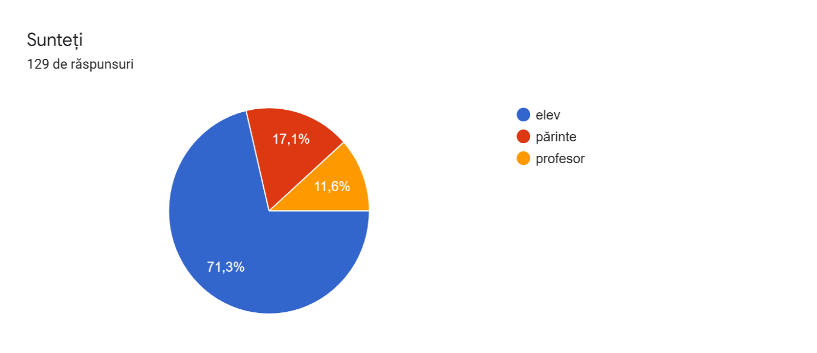
You are
129 answers

student
parent
teacher

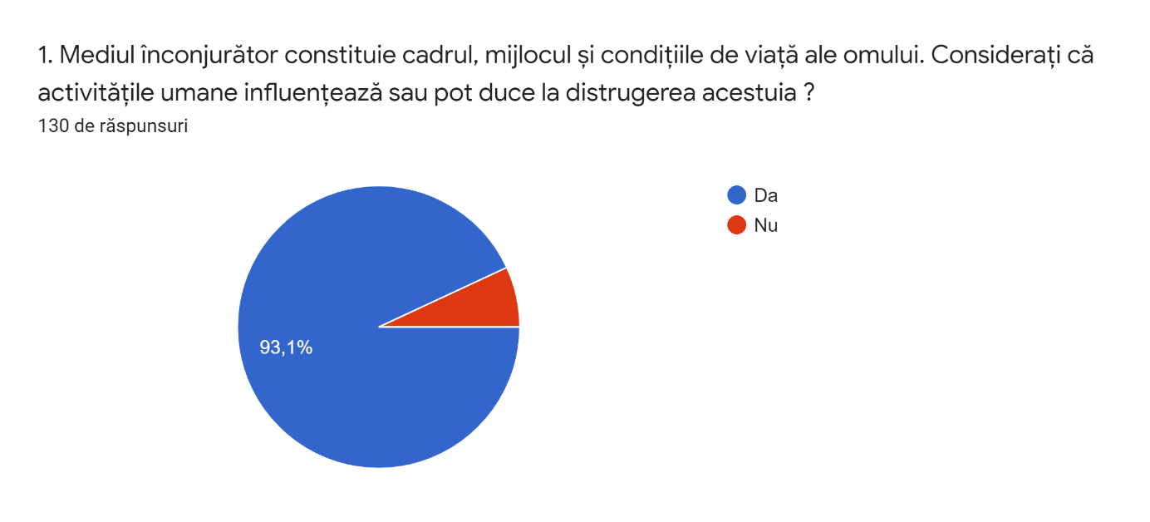
1.The environment constitutes the frame, the means and the conditions of human life. Do you consider that the human activities influence or can lead to its destruction?
130 answers

yes
no

2.What do you think of when you hear about the protection of the environment?
130 answers
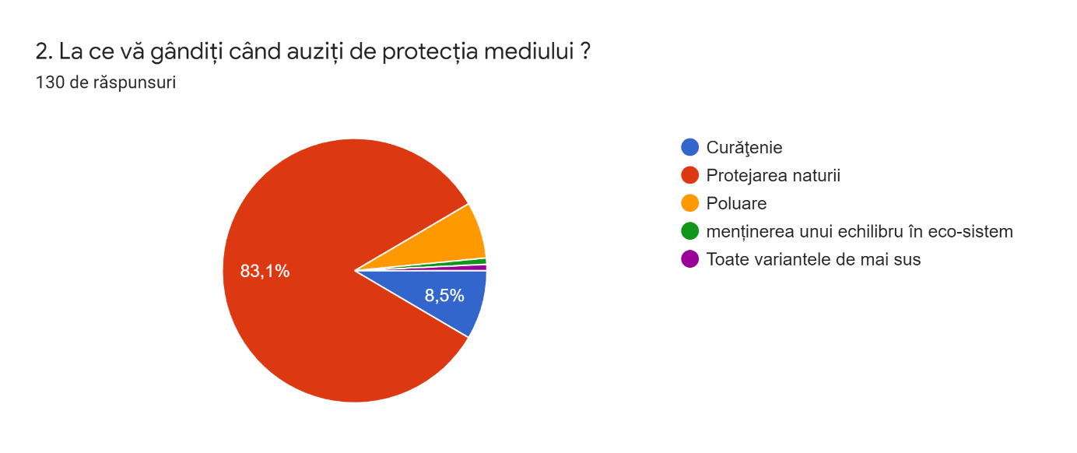

Cleanliness
Protection of nature
Pollution
Maintaining a balanced eco-system
All the options mentioned above

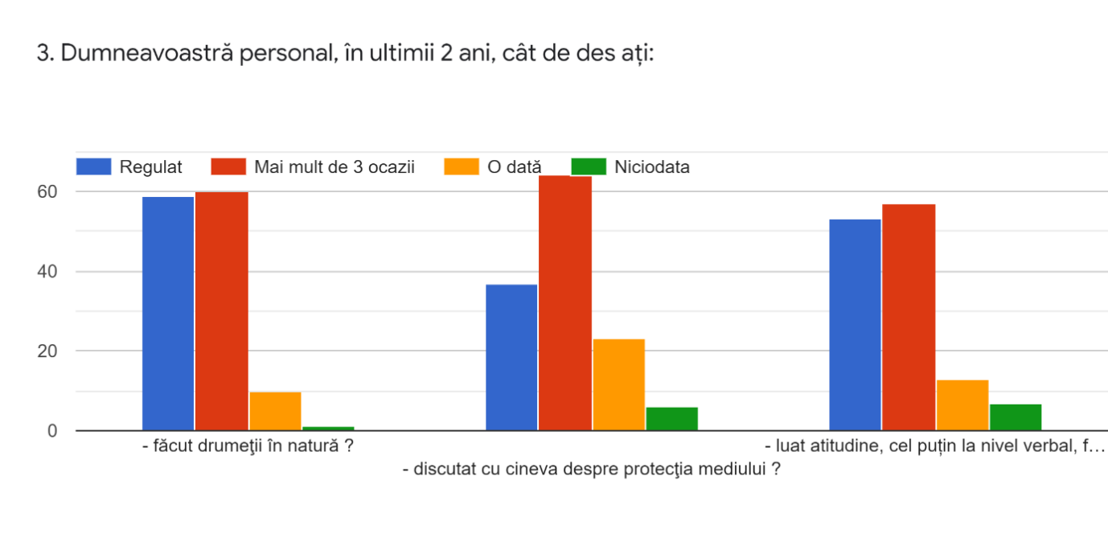
3. In the last two years how often did you:

Once
Never
More than 3 times
Regularly

-go hiking in nature?
-taken attitude, at least verbally
-go hiking in nature?
-discussed with someone about environmental
protection?
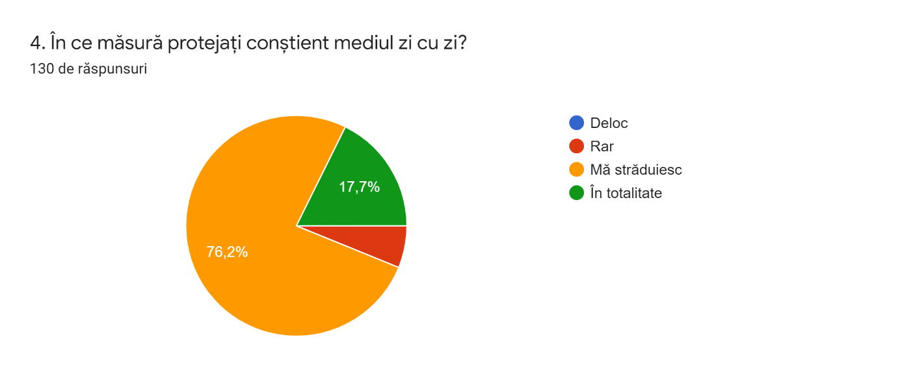
4.To what extent do you protect the environment on a daily basis?
130 answers

At all
Rarely
I try
Always

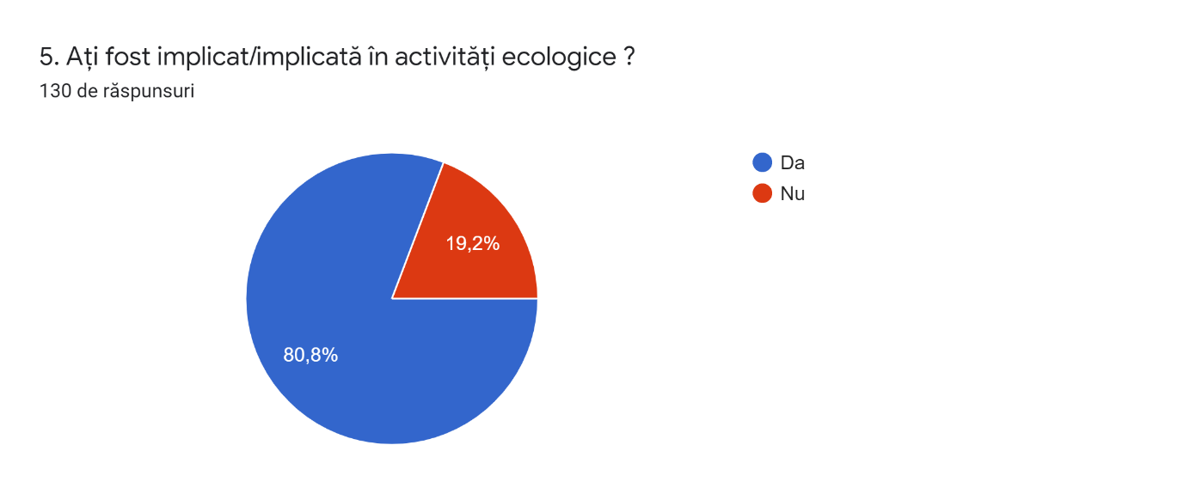
5. Have you ever been involved in ecological activities?
130 answers

yes
no

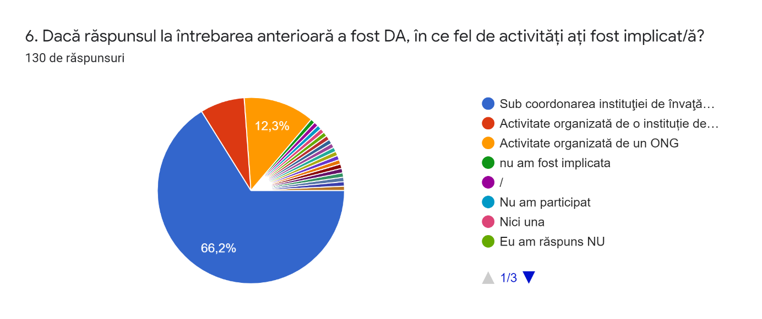
6. If your answer at the previous question was YES, in what type of activities were you involved?
130 answers

Under the quidance of the institution
Activity organized by an institution
Activity organized by non- governmental organization
I was not involved
/
I have not participated
None
I answered NO

7. How do you react if you are asked to join in as a member of a non-governmental organization concerned about environmental protection?
130 answers
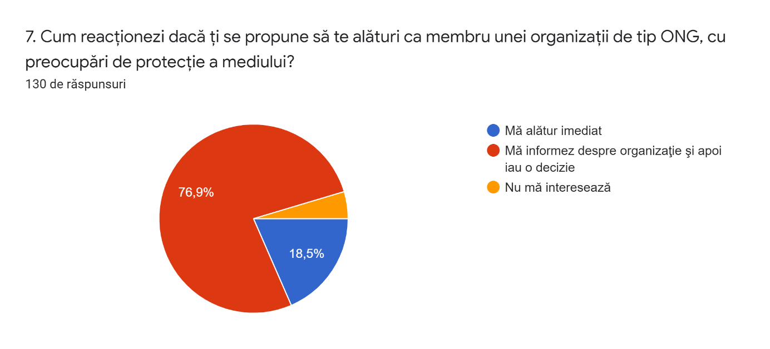
I join immediatelly
I get informed about the organization,
then I make a decision
I am not interested

8. Do you encourage the ecological activities despite the appearance of COVID-19?
130 answers
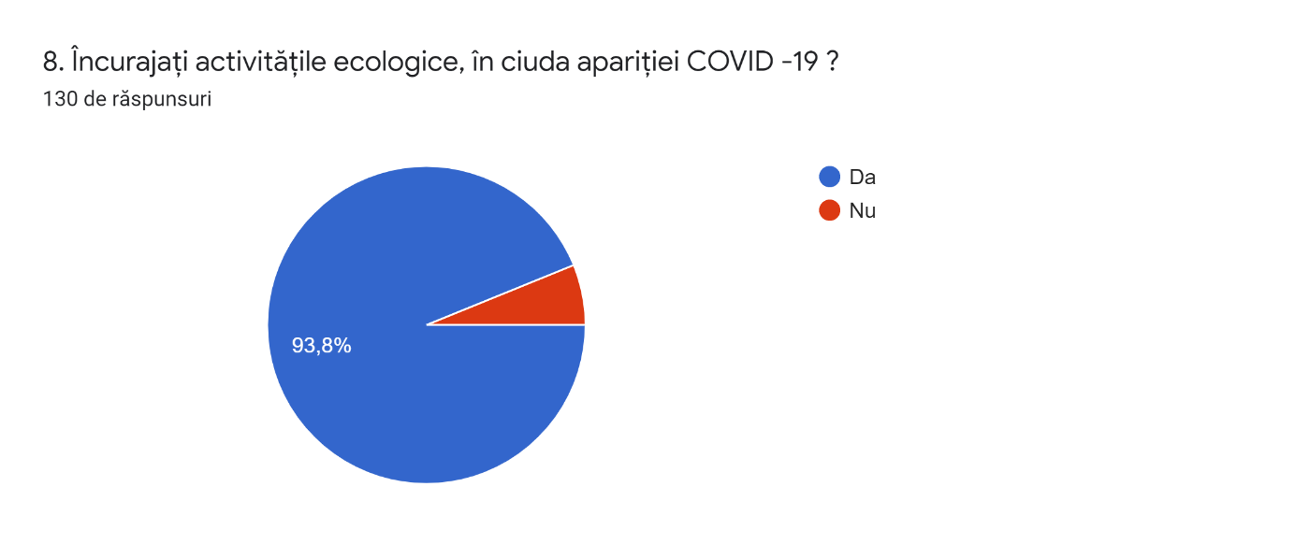

yes
no

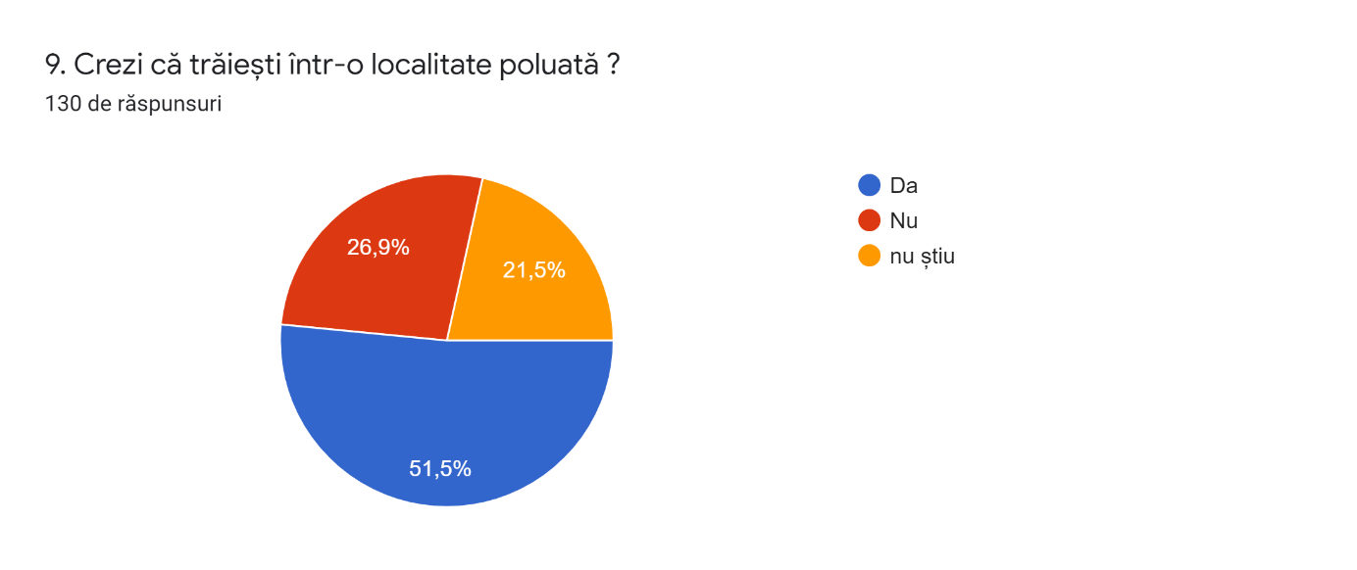
9. Do you think you live in a polluted place?
130 answers
yes
no
I do not know

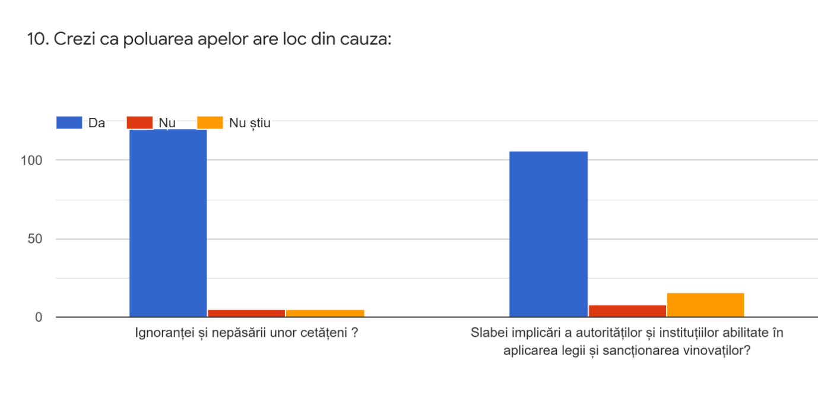
10. Do you think that the water pollution takes place because of...
No
yes
I do not know

the poor implication of authorities and specialized institutions in reinforcing the law by punishing the ones who break the law?
ignorance and carelessness of the citizens?
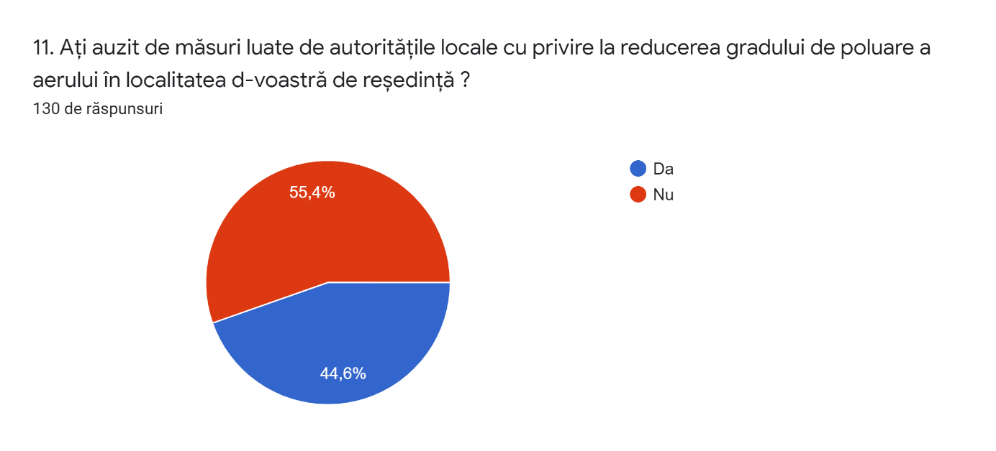
11. Have you heard of measures taken by the local authorities regarding the reduction of the degree of pollution in your area?
130 answers

yes
no

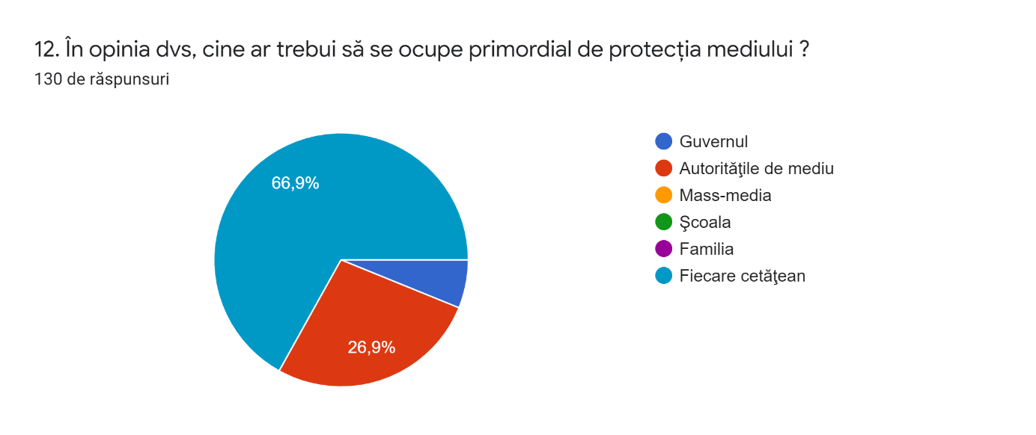
12. In your opinion who should ensure the protection of the environment first and foremost?
130 answers
The government
The authorities for the environment
Mass medis
School
Family
Each citizen

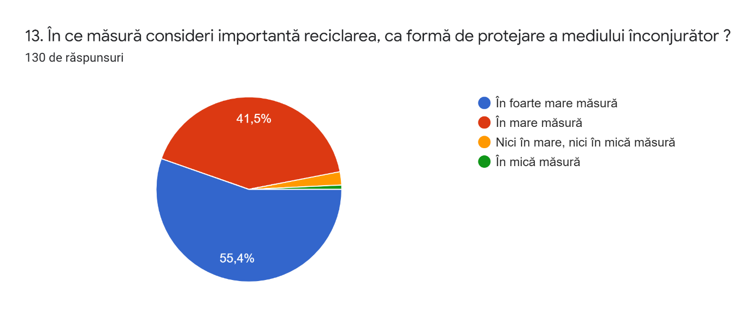
13. To what extent do you consider recycling important as a form of protecting the environment?
130 answers
Tremendously
A lot
Relatively much
A litlle

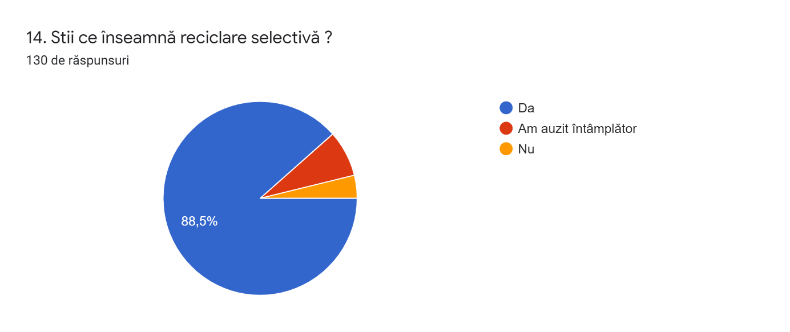
14. Do you know what selective recycling means?
130 answers
yes
I heard by chance
no

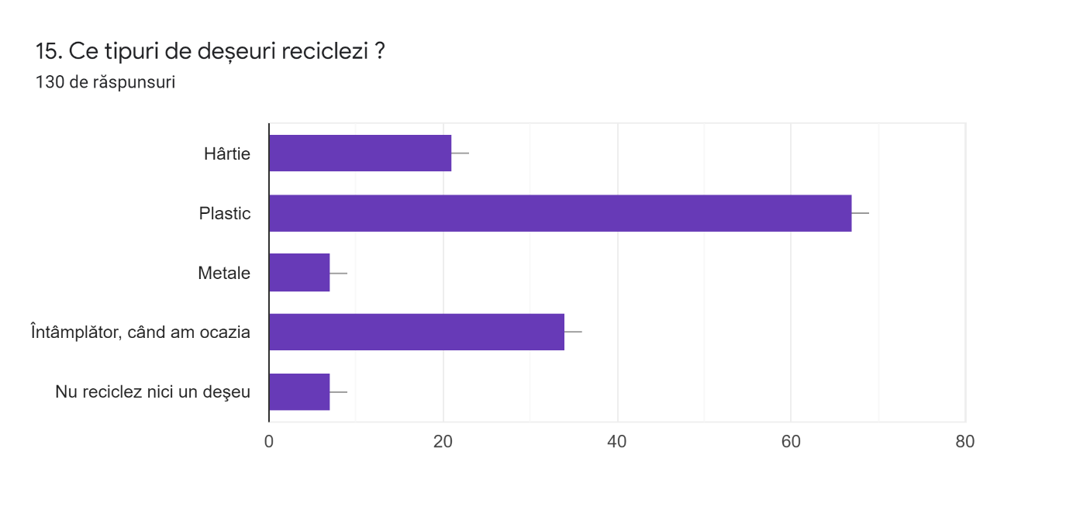
15. What type of waste do you recycle?
130 answers
Metal
Paper
By chance, when I have the chance to do it
I do not recycle any waste

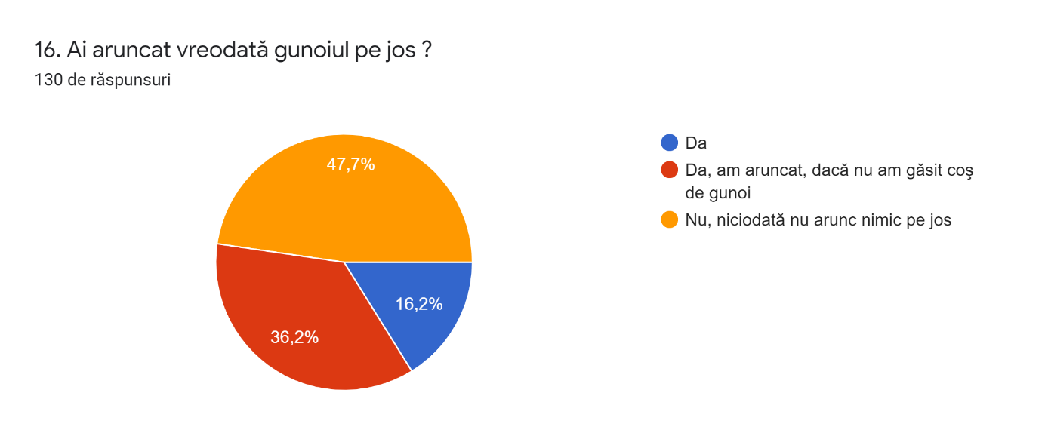
16. Have you ever dropped litter in the street?
130 answers
Yes
Yes, I dropped it if I did not find a bin

No, I never drop litter

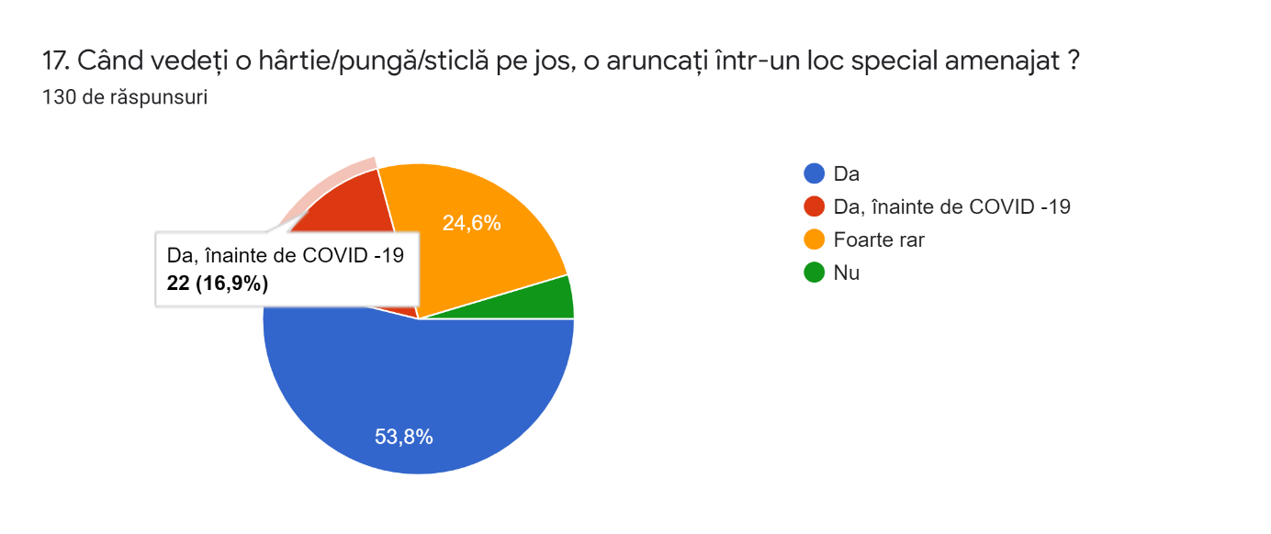
17. When you find a piece of paper/ a bag/ a bottle on the ground do you deposit it in a special place?
130 answers

130 answers
Yes
Yes, before COVID-19
Rarely
No
Yes, before COVID-19
22 (16.9%)

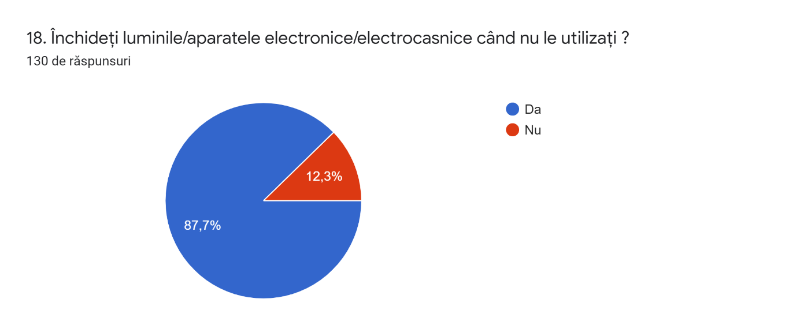
yes
no
18. Do you turn off the lights/ electrical appliances/ gadgets when you do not use them?
130 answers

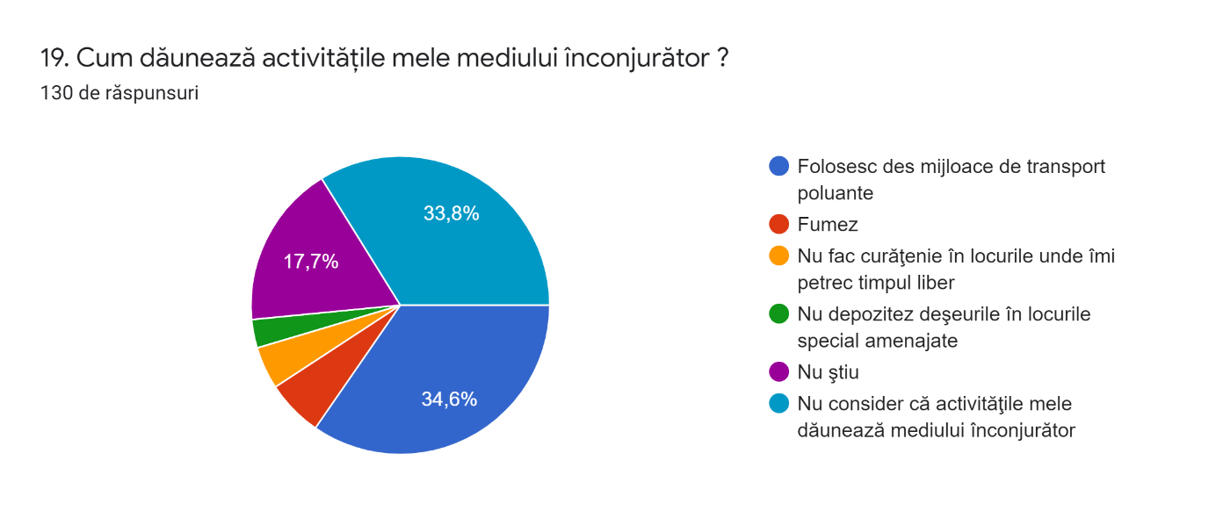
19. How do your activities affect the environment?
130 answers
I use means of transport that pollute

I smoke
I do not clean the place where I spend my free time

I do not deposit the waste in specially designed places

I do not know
I do not consider my activities affect the environment

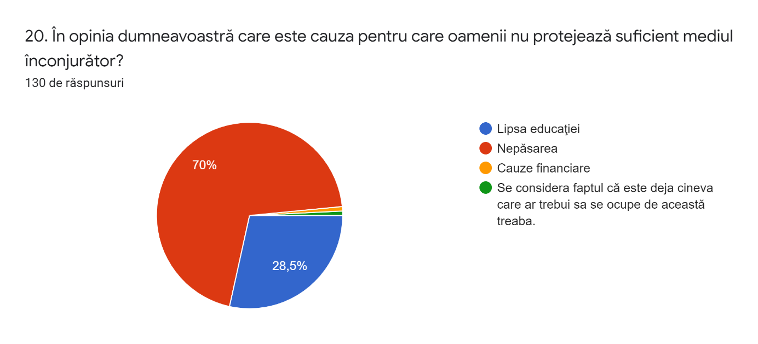
20. In your opinion, which is the reason why people do not protect the environment?
130 answers
Lack of education
Carelessness
Financial reasons
They consider there is already someone who should take care of this

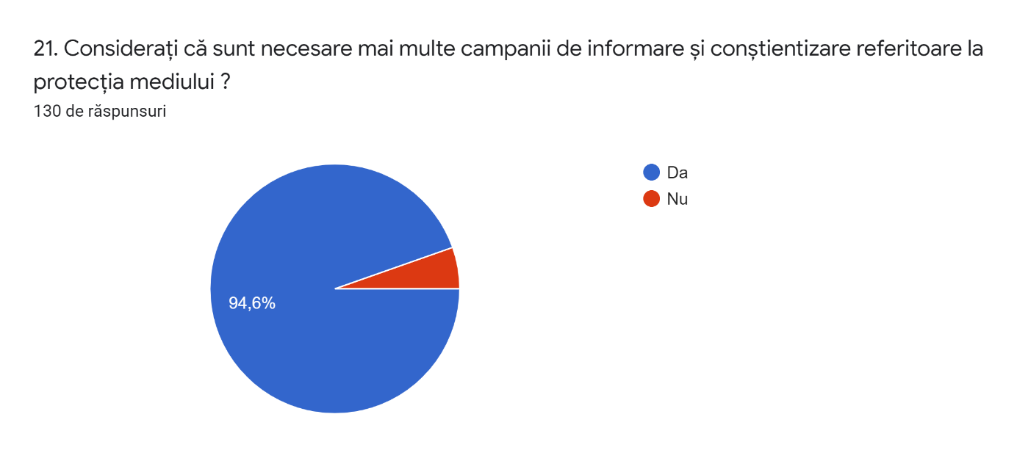
21. Do you consider necessary more informative campaigns concerning the environment meant to raise people’ s awareness of the importance of its preservation?
130 answers
yes
no

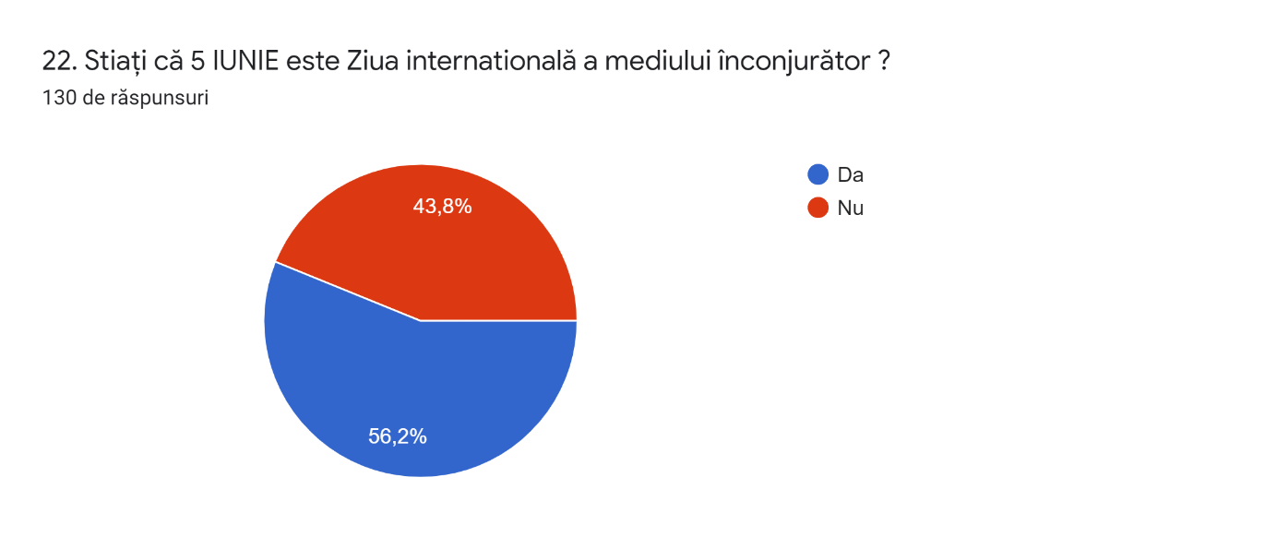
22. Did you know that 5th June is the international day of the environment?
130 answers
yes
no

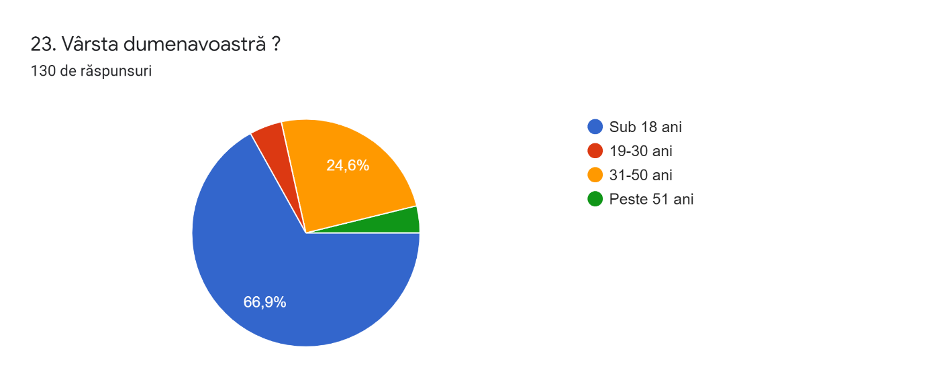
Under 18
19-30 years old
31-50 years old
51+
23. What is your age?
130 answers

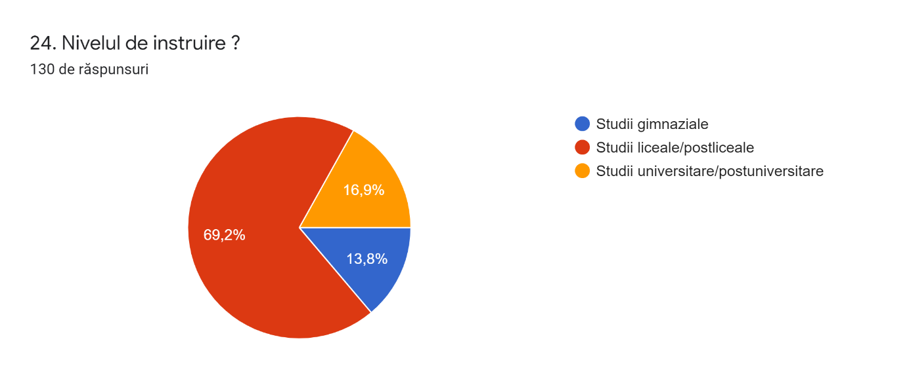
Lower secondary school
Higher secondary school/ high-school
University/ post university studies
24. What is your level of formal education?
130 answers

25. Your residential area?
130 answers
